28-05-2025(MONGODB)

**NAME:** Ch.Eswara Balaji

1) Product s dataset with 5 fields

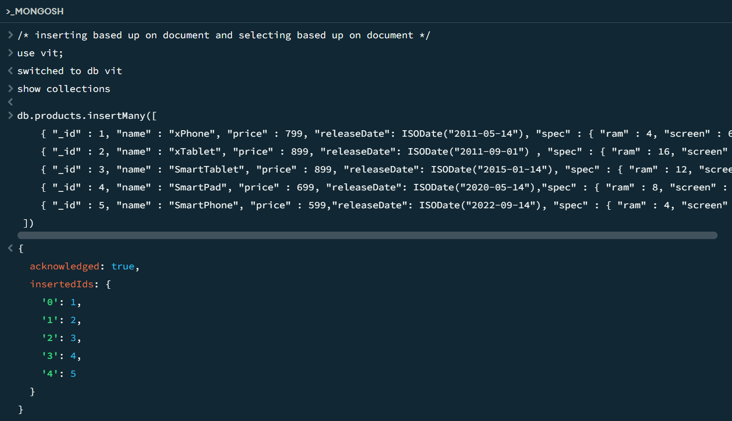

2) Finding the first column of the dataset

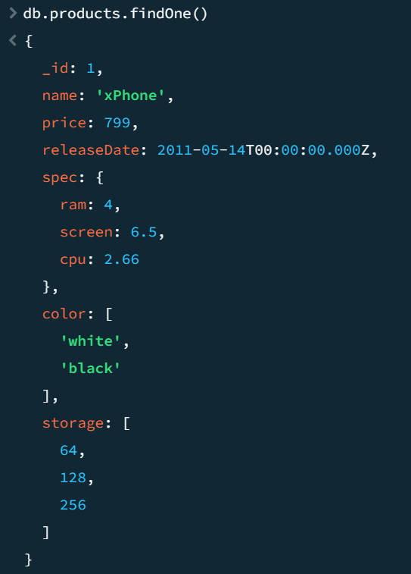

3) Finding the one column but based up on only the **id**

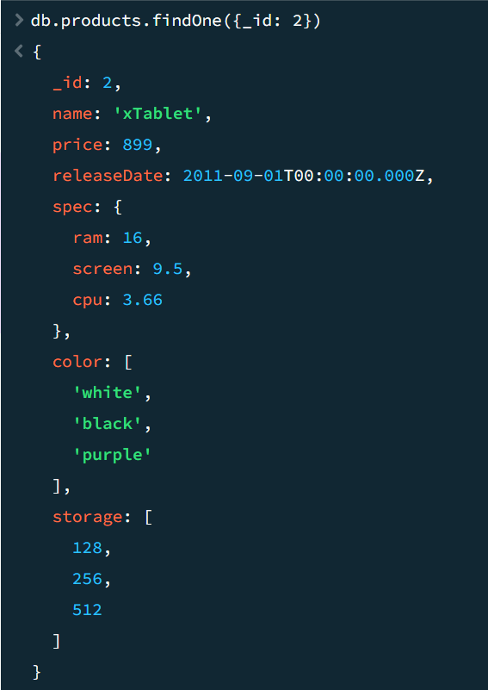

4) Finding based upon:

a) id, name  
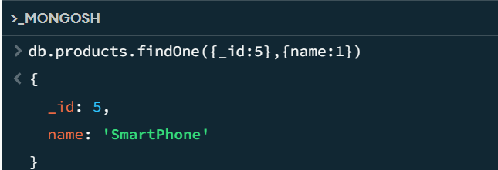

b) only name it should show

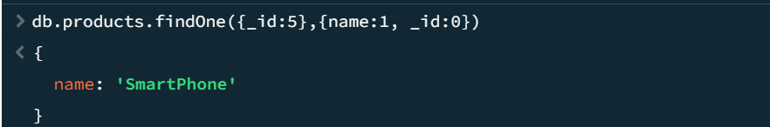

5) Finding the one column but based up on only the **name**

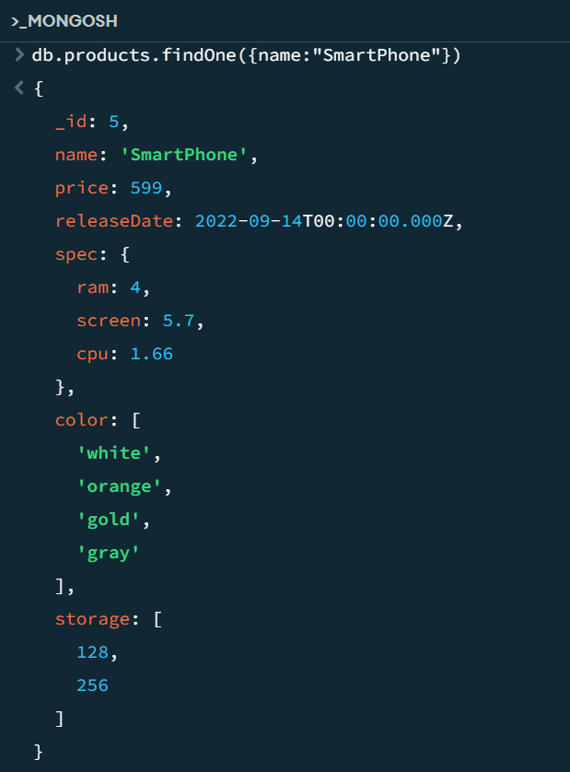

6)Inserting books collections

db.books.insertMany([

{ "_id" : 1, "title" : "Unlocking Android", "isbn" : "1933988673", "categories" : [ "Open Source", "Mobile" ] },

{ "_id" : 2, "title" : "Android in Action, Second Edition", "isbn" : "1935182722", "categories" : [ "Java" ] },

{ "_id" : 3, "title" : "Specification by Example", "isbn" : "1617290084", "categories" : [ "Software Engineering" ] },

{ "_id" : 4, "title" : "Flex 3 in Action", "isbn" : "1933988746", "categories" : [ "Internet" ] },

{ "_id" : 5, "title" : "Flex 4 in Action", "isbn" : "1935182420", "categories" : [ "Internet" ] },

{ "_id" : 6, "title" : "Collective Intelligence in Action", "isbn" : "1933988312", "categories" : [ "Internet" ] },

{ "_id" : 7, "title" : "Zend Framework in Action", "isbn" : "1933988320", "categories" : [ "Web Development" ] },

{ "_id" : 8, "title" : "Flex on Java", "isbn" : "1933988797", "categories" : [ "Internet" ] },

{ "_id" : 9, "title" : "Griffon in Action", "isbn" : "1935182234", "categories" : [ "Java" ] },

{ "_id" : 10, "title" : "OSGi in Depth", "isbn" : "193518217X", "categories" : [ "Java" ] },

{ "_id" : 11, "title" : "Flexible Rails", "isbn" : "1933988509", "categories" : [ "Web Development" ] },

{ "_id" : 13, "title" : "Hello! Flex 4", "isbn" : "1933988762", "categories" : [ "Internet" ] },

{ "_id" : 14, "title" : "Coffeehouse", "isbn" : "1884777384", "categories" : [ "Miscellaneous" ] },

{ "_id" : 15, "title" : "Team Foundation Server 2008 in Action", "isbn" : "1933988592", "categories" : [ "Microsoft .NET" ] },

{ "_id" : 16, "title" : "Brownfield Application Development in .NET", "isbn" : "1933988711", "categories" : [ "Microsoft" ] },

{ "_id" : 17, "title" : "MongoDB in Action", "isbn" : "1935182870", "categories" : [ "Next Generation Databases" ] },

{ "_id" : 18, "title" : "Distributed Application Development with PowerBuilder 6.0", "isbn" : "1884777686", "categories" : [ "PowerBuilder" ] },

{ "_id" : 19, "title" : "Jaguar Development with PowerBuilder 7", "isbn" : "1884777864", "categories" : [ "PowerBuilder", "Client-Server" ] },

{ "_id" : 20, "title" : "Taming Jaguar", "isbn" : "1884777686", "categories" : [ "PowerBuilder" ] },

{ "_id" : 21, "title" : "3D User Interfaces with Java 3D", "isbn" : "1884777902", "categories" : [ "Java", "Computer Graphics" ] },

{ "_id" : 22, "title" : "Hibernate in Action", "isbn" : "193239415X", "categories" : [ "Java" ] },

{ "_id" : 23, "title" : "Hibernate in Action (Chinese Edition)", "categories" : [ "Java" ] },

{ "_id" : 24, "title" : "Java Persistence with Hibernate", "isbn" : "1932394885", "categories" : [ "Java" ] },

{ "_id" : 25, "title" : "JSTL in Action", "isbn" : "1930110529", "categories" : [ "Internet" ] },

{ "_id" : 26, "title" : "iBATIS in Action", "isbn" : "1932394826", "categories" : [ "Web Development" ] },

{ "_id" : 27, "title" : "Designing Hard Software", "isbn" : "133046192", "categories" : [ "Object-Oriented Programming", "S" ] },

{ "_id" : 28, "title" : "Hibernate Search in Action", "isbn" : "1933988649", "categories" : [ "Java" ] },

{ "_id" : 29, "title" : "jQuery in Action", "isbn" : "1933988355", "categories" : [ "Web Development" ] },

{ "_id" : 30, "title" : "jQuery in Action, Second Edition", "isbn" : "1935182323", "categories" : [ "Java" ] }

]);

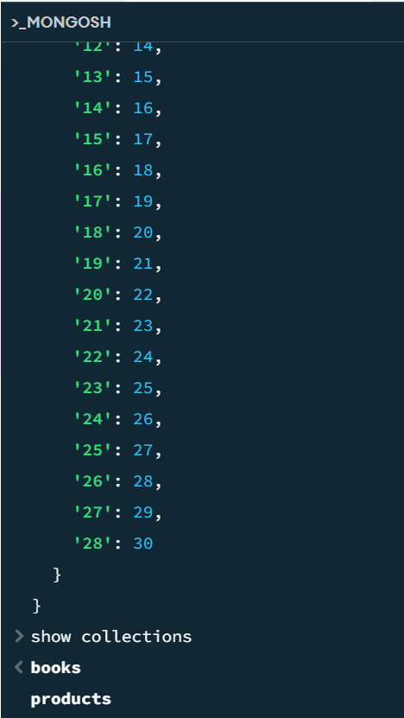

7) Finding the data that with only using name and price

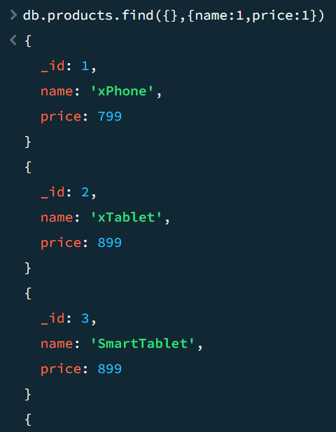 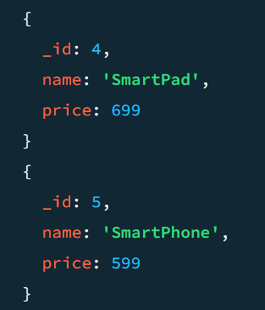

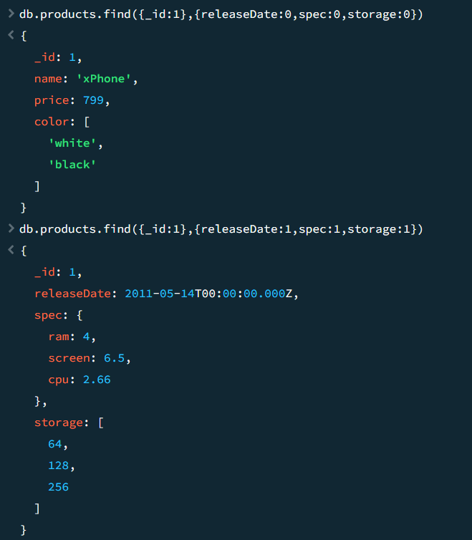

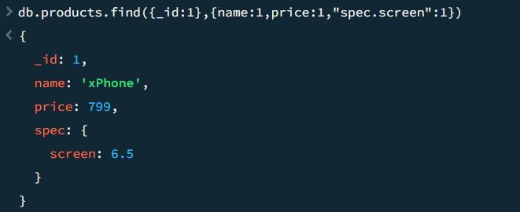

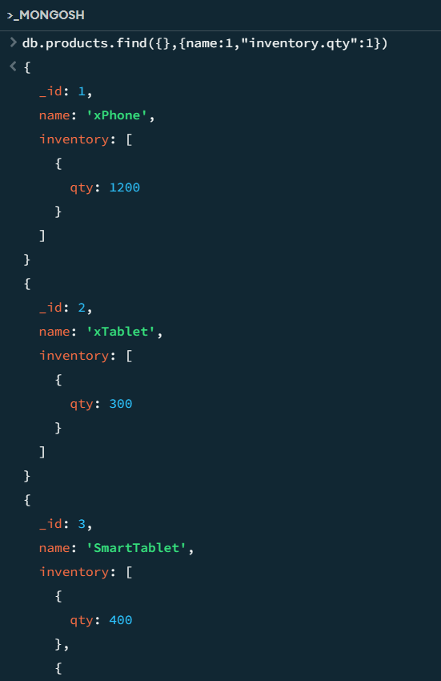 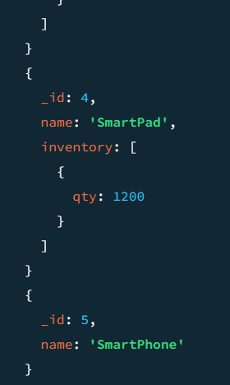

**Operators($):**

**1)equal to operator(when it is exactly the value is given)**

**a)using equal to operator:$eq**

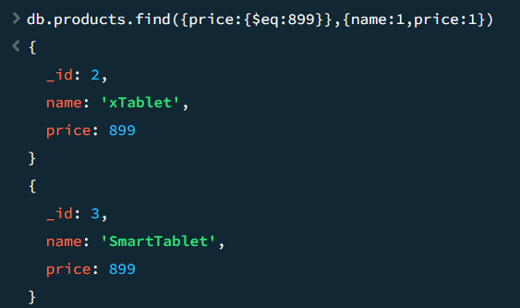

**b) Without equal to also u can find the next the same one**

